Max Bender

Lab 1

Dragon



The advantages of using C as a target language for a compiler is useful because it is a very low level language. This means that it utilizes memory allocation and other low level aspects not found in higher level (i.e. Java). This produces more efficient machine code and there for a faster program/compiler.



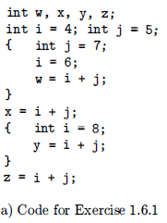

W = 13

X = 11

Y = 13

Z = 11

Not Dragon

1.11? Not found?

3.1

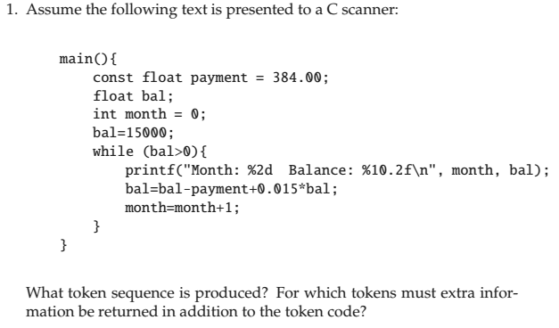

Keyword, keyword, id, assignment, int, keyword, id, keyword, id, assignment, int, keyword, openParen, id, intop, int, closeParen, openBracket, keyword, openParen, String, closeParen, id, assignment, id, intop, keyword, intop, int, intop, id, id, assignment, id, intop, int, closeBracket, closeBracket

The Id’s need more information to be sent back with the token code because we also need to recall the values of the id’s as well.